***P R O F I L E***

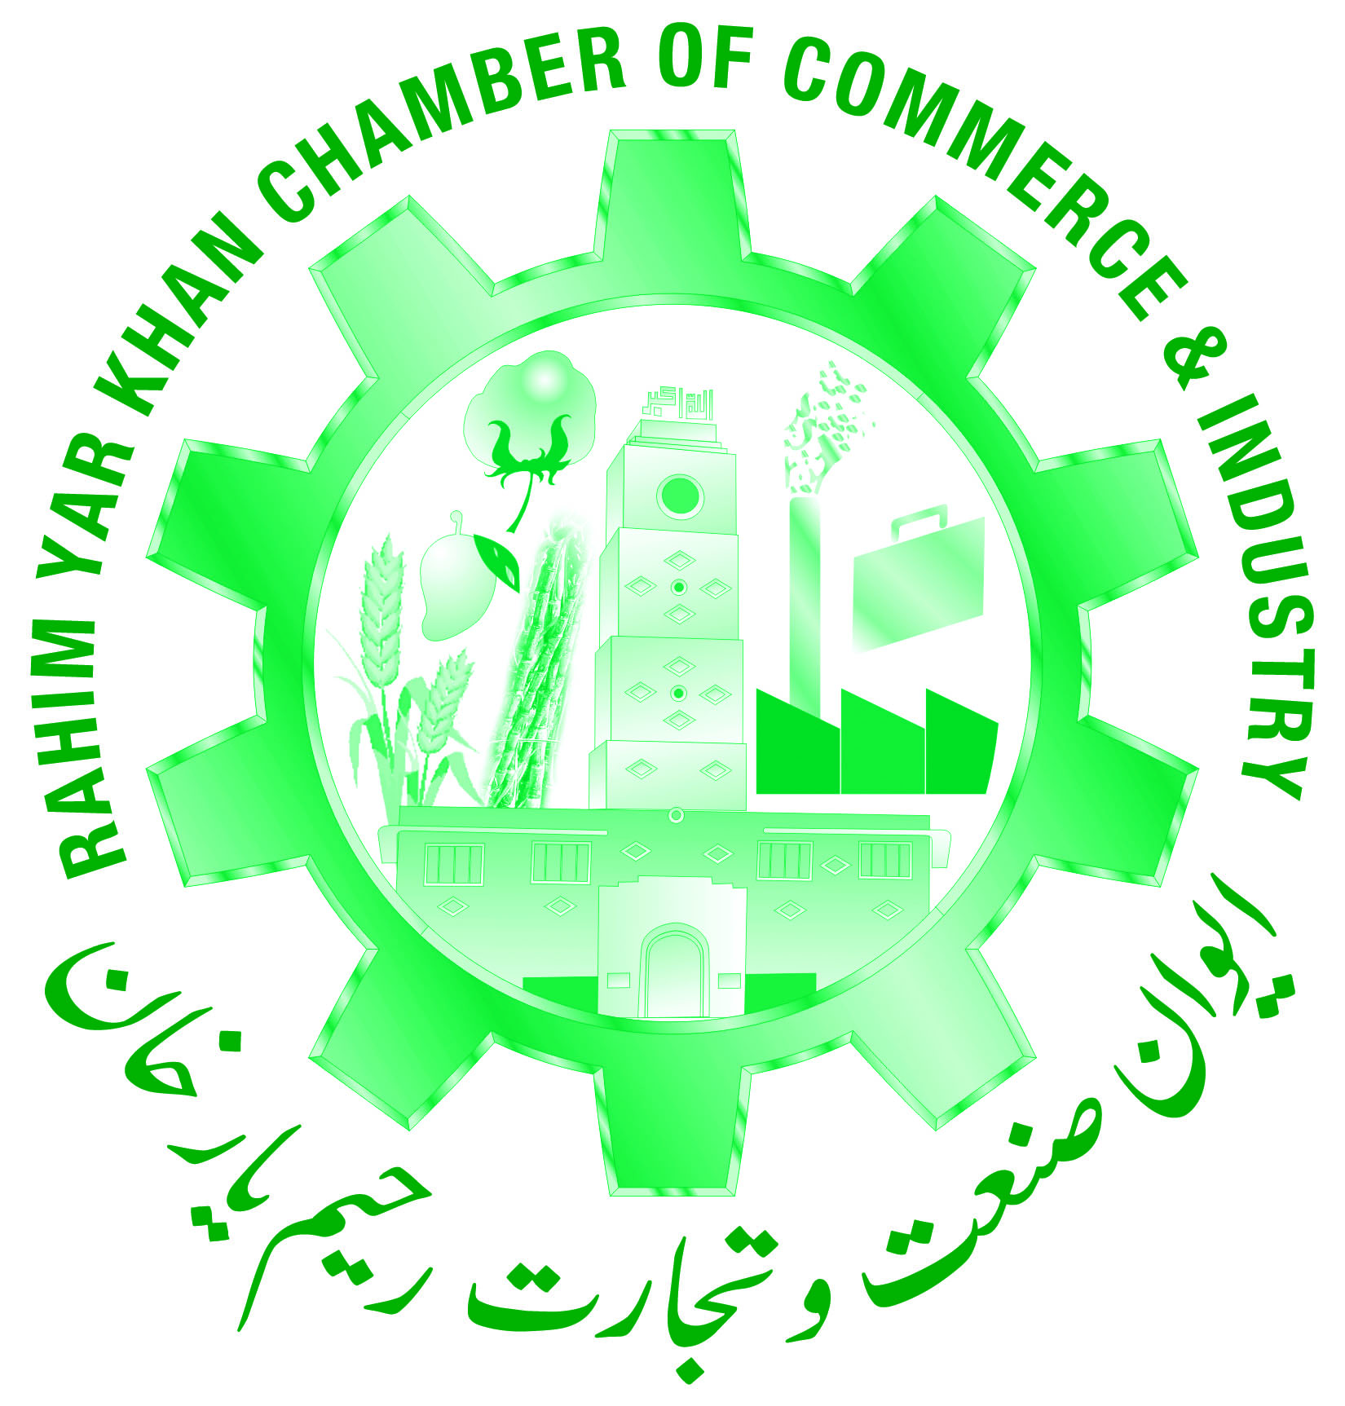

# RAHIM YAR KHAN

# CHAMBER OF COMMERCE & INDUSTRY

SHAHBAZPUR ROAD, RAHIM YAR KHAN, PAKISTAN

**PHONE:** +92(68) 9230008, 5889424 **FAX:** +92(68) 9230009

**E-MAIL:** info@rykchamber.com

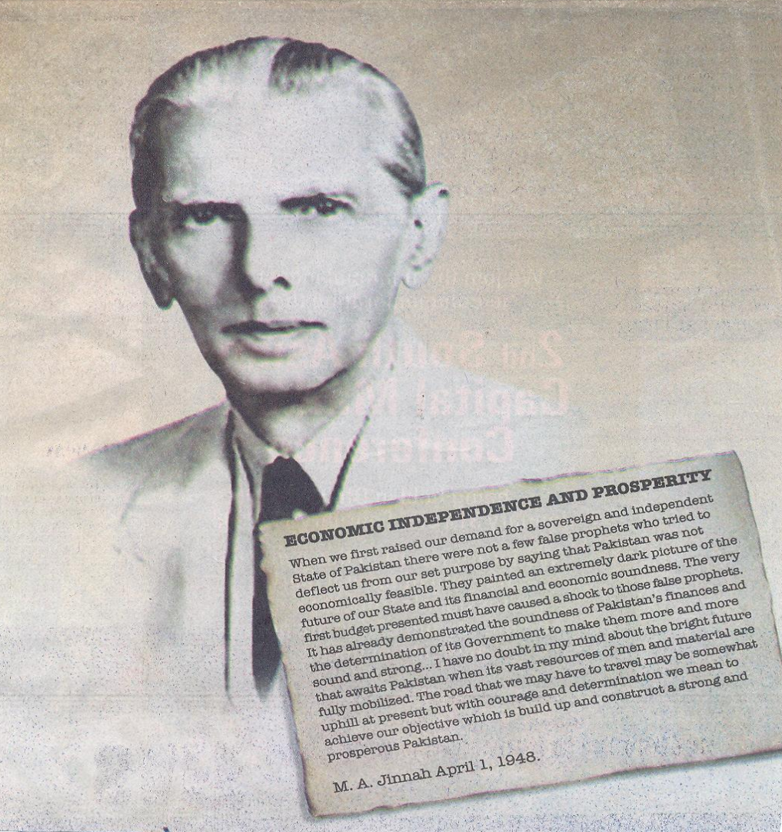

**Introduction:**

**RAHIM YAR KHAN CHAMBER OF COMMERCE & INDUSTRY** [RYKCCI]

RAHIM YAR KHAN CHAMBER OF COMMERCE & INDUSTRY is an apex trade body of District RAHIM YAR KHAN, established in July-2007, and playing a vital role to create a positive climate for business growth in the area. Within initial few years of its establishment, our chamber's membership strength has reached 3800+ members, which is highest in chambers of southern Punjab.

**Vision:**

The Vision of the Rahim Yar Khan Chamber of Commerce & Industry is to be a Unified and cooperative body, to speak as one voice, to develop a strong positive working relationship with the community and thereby becoming more successful at our individual businesses.

**Mission:**

The mission of the Rahim Yar Khan Chamber of Commerce & Industry is to Promote, Support, Educate and Develop the City, Businesses and Industries in Rahim Yar Khan & Pakistan, to make it a desirable place to live, work and raise a family and conduct business.

* **District Rahim Yar Khan**

**Profile**

**INTRODUCTION**

Rahim Yar Khan is a famous city in the south of Punjab (Pakistan). Rahim Yar Khan is the capital city of Rahim Yar Khan District as well as the tehsil of the same name. Rahim Yar khan district was declared as a separate administration district in 1943. The previous name of this city was Naushehra which was built in 1875 A.D by Fazal Elahi Halani on the ruins of the ancient Pul-Wadda during the Sumra supremacy in Sindh. In the year 1881, the Railway Authorities desired to change is name of railway station because in the name of a town called Nowshera situated in Peshawar district. Consequently in 1881 to avoid any confusion because of similar nomenclature, Nawab Sadiq Khan-IV of Bahawalpur changed the name of the sub-division Naushehra after the name of his first son crown prince Rahim Yar Khan.

**Key Economic Facts: District RAHIM YAR KHAN**

* District RAHIM YAR KHAN is located at very strategic position at the borders of Sindh and Baluchistan provinces.
* According to current government of Punjab statistics, population-wise Rahim Yar Khan is the 5th largest district of Punjab, bigger than Multan and area-wise it stand 4th largest district of Punjab.
* District RAHIM YAR KHAN is one of the largest producers of raw cotton, wheat, sugar cane, Mangos,Seed,Fertilizer and rice
* 1/3rd of the total mango production of Pakistan is produced in the district R Y Khan.
* There are Over 124-Cotton Ginning Factories, 100+Flour Mills, 90+ Oil Mills 7-Sugar Mills, 03-Textile Units, 26-Power Loom Factories, 2-Fertilizer Companies, 160+ Seed Companies,57 Auto Industry,32 Poultry Industry, 70+ Pesticide Firms, 7-Sugar Mills,7- Rice Export Factories, 2-OIL and Ghee Mills,1-pharmaceutical Industry,3 big Units of Agriculture Implements,04 Units of Cold Storage and Multinational Companies like Coca Cola and Unilever Pakistan are operating in district while Sheikh Zayed Medical College , Khawaja Freed University of Engineering and information and Technology (KFUEIT), Islamia University Bahawalpur, Rahim Yar Khan Campus are also located here.
* Because of rich in resources, easy availability of raw materials and low production costs, a big potential for the establishment of new manufacturing / industrial units in the district is available.
* Best Agriculture land, Mango crop, Wheat, Rice, Sugar Can, Cotton etc.
* Industrial Estate ( Special Economic Zone )